**Capstone final project- The battle of neighborhood of Paris- Repport**

1. **PURPOSE**

This document provides the report of my final capstone project for the IBM Data Science Professional Certificate.

1. **INTRODUCTION**

I have more than 20 years of experience in catering. As owner and as manager. This profession is important to me and I want to continue in this area. My dream project is to open a franchise of Japanese restaurants. It's a new concept of restaurant without waitress. Food moves on a conveyor to the customer and the customer chooses what he wants to eat. I expect that this concept will be very successful because people here in France love Japanese food. The idea is to open a first franchise of this restaurant in a strategic location in Paris, deploy the necessary efforts for it's success and then open other franchises in the various boroughs of Paris and in the other cities.

1. **Objective**

In this project, we will study the areas of Paris order to determine which neighborhoods have the highest concentration of sushi restaurant in order to solve our business problem.

**A description of the problem and discussion of the background**

The challenge to resolve is being able to find a place in Paris to open my new restaurant with the following conditions: - located in place with less competition.

**Interested Audience**

I believe this is a relevant project for any person how want to open a restaurant in any city, it will be very interesting for franchises companies. The approach and methodologies used are applicable for all cases.

1. **Methodology**

**Data Required to resolve the problem**

To do that, we will use the Foursquare API to explore neighborhoods in Paris. We will use the explore function to get the most common venue categories in each neighborhood, and then use this feature to group the neighborhoods into clusters. We will use the k-means clustering algorithm to complete this task.

1. **Segmenting and Clustering Neighborhoods**

Neighborhood has a total 20 neighborhoods called "Arrondissement" . In order to segment these "Arrondissement" and explore them, we will essentially need a dataset that contains the neighborhoods as well as the the latitude and longitude coordinates of each neighborhood.

**Load and explore the data**

The data regarding neighborhood where loaded from Wikipedia and transformed in dataframe.

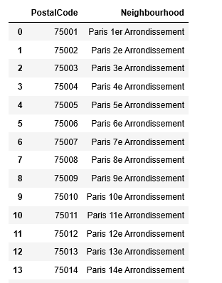

**Geographical coordinates**

Using **geopy.geocoders** we loaded we loaded latitudes and longitudes for each neighborhood of Paris and added the to our dataframe. Them we create a map of Paris neighborhood.

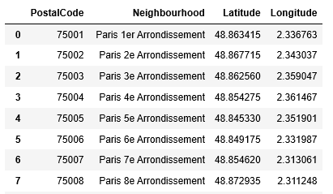

**2. Explore Neighborhoods od Paris**

We used Foursquare API to explore avenues of Paris neighborhoods.

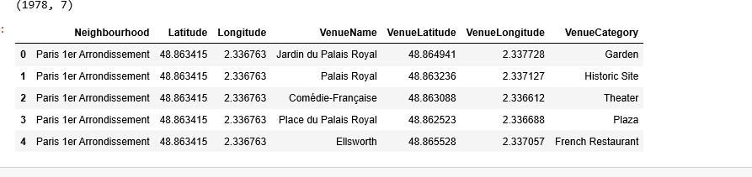

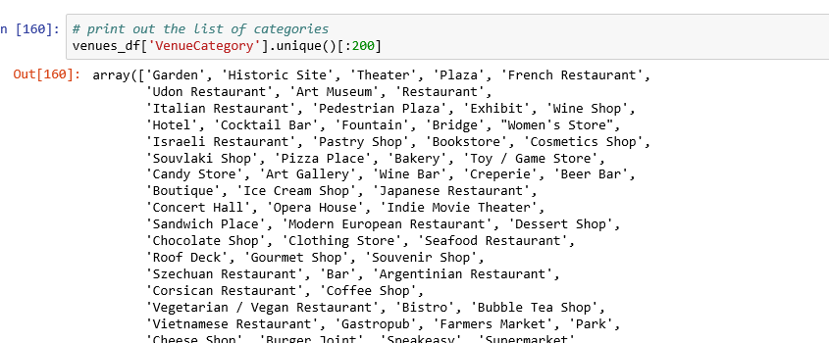

**Analyze Each Neighborhood**

We cluster avenue for category Sushi restaurant.

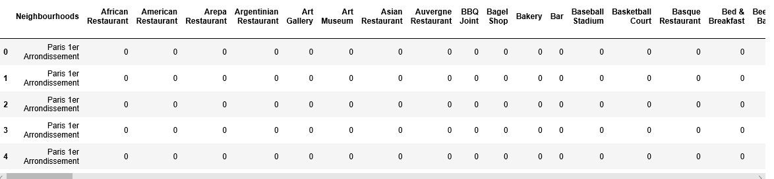

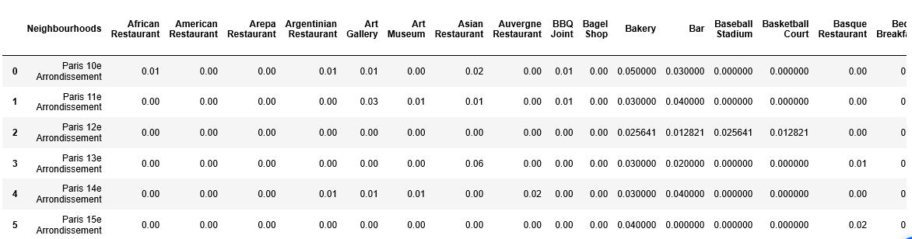

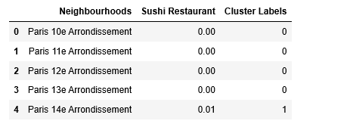

**3.Results Section**

We followed the methodology that way described above and came to the conclusion that most neighborhood of Paris represent a good opportunity to lunch the new concept of Sushi Restaurant since the was less competition in most of the areas.

**4.Discussion Section**

Observations that I made during this analysis were that Paris has many areas and neighborhoods where we can start a new concept Sushi Restaurant . Knowing that people in Paris are very open to Asian food that will encourage us to invest in this type of restaurants.

**5.Conclusion Section**

In conclusion, we have shown that k-means clustering combined with Foursquare API data can be used to make business recommendations. We were able to cluster area in a specific neighborhood that optimizes our chances for success.